https://builtin.com/data-science/step-step-explanation-principal-component-analysis

Principal component analysis (PCA) is a dimensionality reduction technique that transforms a data set into a set of orthogonal components — called principal components — which capture the maximum variance in the data. PCA simplifies complex data sets while preserving their most important structures.
What Is Principal Component Analysis?
Principal component analysis (PCA) is a dimensionality reduction and machine learning method used to simplify a large data set into a smaller set while still maintaining significant patterns and trends.
What Are Principal Components?
- Principal components are new variables that are constructed as linear combinations or mixtures of the initial variables.
- These combinations are done in such a way that the new variables (i.e., principal components) are uncorrelated and most of the information within the initial variables is squeezed or compressed into the first components.
- So, the idea is 10-dimensional data gives you 10 principal components, but PCA tries to put maximum possible information in the first component, then maximum remaining information in the second and so on, until having something like shown in the scree plot below.
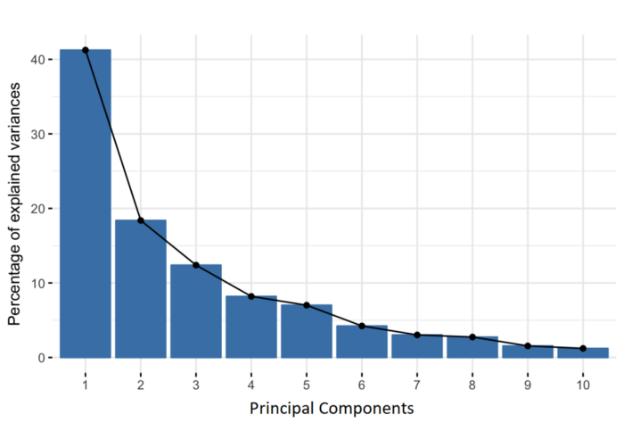

Organizing information in principal components this way will allow you to reduce dimensionality without losing much information, and this by discarding the components with low information and considering the remaining components as your new variables.
An important thing to realize here is that the principal components are less interpretable and don’t have any real meaning since they are constructed as linear combinations of the initial variables.
Geometrically speaking, principal components represent the directions of the data that explain a maximal amount of variance, that is to say, the lines that capture most information of the data.
The relationship between variance and information here, is that, the larger the variance carried by a line, the larger the dispersion of the data points along it, and the larger the dispersion along a line, the more information it has.
To put all this simply, just think of principal components as new axes that provide the best angle to see and evaluate the data, so that the differences between the observations are better visible.

How PCA Constructs the Principal Components
As there are as many principal components as there are variables in the data, principal components are constructed in such a manner that the first principal component accounts for the largest possible variance in the data set.
For example, let’s assume that the scatter plot of our data set is as shown below, can we guess the first principal component ? Yes, it’s approximately the line that matches the purple marks because it goes through the origin and it’s the line in which the projection of the points (red dots) is the most spread out. Or mathematically speaking, it’s the line that maximizes the variance (the average of the squared distances from the projected points (red dots) to the origin).



The second principal component is calculated in the same way, with the condition that it is uncorrelated with (i.e., perpendicular to) the first principal component and that it accounts for the next highest variance.
This continues until a total of p principal components have been calculated, equal to the original number of variables.

Applications of Principal Component Analysis
Principal component analysis has applications across data science, machine learning and engineering fields, helping improve data analysis, visualization and computing performance in various tasks.
Here are some of its most common applications:
1. Data Visualization
PCA reduces high-dimensional data to a two-dimensional or three-dimensional space for easier visualization, helping to reveal data trends, clusters or outliers.
2. Preprocessing for Machine Learning
PCA is often used before applying machine learning algorithms in order to reduce dimensionality, speed up training and improve model generalization.
3. Feature Extraction
PCA transforms correlated data features into a smaller set of uncorrelated components, which can help improve model performance and interpretability.
4. Data Compression
PCA reduces data storage needs by representing data with fewer dimensions while preserving most of its variability, making it effective in image and signal compression.
5. Noise Reduction
By filtering out low-variance components, PCA can reduce noise in data for applications like image and audio.
To find out PCA in machine learning using the student performance example, follow these step-by-step statistical and computational steps:

Step-by-Step PCA Computation
1. Standardize the Data
PCA is sensitive to scale. Convert all features to have mean = 0 and standard deviation = 1.
For each feature (e.g., GPA, Attendance), compute:
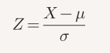
Where:
- (X) is the original value
- (\mu) is the mean of the feature
- (\sigma) is the standard deviation

2. Compute the Covariance Matrix
This matrix shows how features vary together.
For standardized data matrix (X), compute:
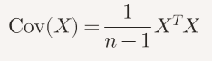

3. Calculate Eigenvalues and Eigenvectors
- Eigenvectors represent the directions (principal components).
- Eigenvalues represent the magnitude (variance explained).
Sort eigenvalues in descending order:
- PC1 → largest eigenvalue
- PC2 → second largest, and so on
https://www.geeksforgeeks.org/engineering-mathematics/eigen-values/

4. Feature Selection and Creating a Feature Vector – Selecting Top Components

After calculating eigenvectors and sorting them by eigenvalues (importance), we decide which components to keep.
- Components with high eigenvalues carry more information; those with low eigenvalues can be discarded.
What is a Feature Vector?
- A feature vector is a matrix made of the eigenvectors we choose to keep.
- If we keep only p out of n eigenvectors, we reduce the data to p dimensions.
Example:
- Suppose we have two eigenvectors: v₁ and v₂.
- If v₁ carries 96% of the information and v₂ only 4%, we can:
- Keep both → no loss of information.
- Keep only v₁ → reduce dimensionality with minimal loss.

5. Project Data onto Principal Components
Multiply standardized data by the top (k) eigenvectors:
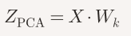
Where:
- (W_k) is the matrix of top (k) eigenvectors
- Result is a new matrix with reduced dimensions (e.g., 5 students × 2 PCs)

EXAMPLE:
Let’s walk through a small numerical example of PCA with Height and Weight so you can see the transformation clearly.

Example Dataset
Suppose we have 4 people with the following data:
Person | Height (cm) | Weight (kg)
A | 170 | 65
B | 160 | 60
C | 180 | 80
D | 175 | 75

Step 1: Feature Scaling
We standardize each feature (subtract mean, divide by standard deviation):
- Mean Height = 171.25, Std ≈ 7.5
- Mean Weight = 70, Std ≈ 8.2
Scaled values (approx):
Person | Height (scaled) | Weight (scaled)
A | -0.17 | -0.61
B | -1.50 | -1.22
C | 1.17 | 1.22
D | 0.50 | 0.61

Step 2: Covariance Matrix & Eigenvectors
- PCA computes eigenvectors of the covariance matrix.
- For this dataset, the first principal component (PC1) roughly aligns with the direction where both Height and Weight increase together.
- The second principal component (PC2) captures the smaller variation orthogonal to PC1.
- We compute how Height and Weight vary together.
Here, the covariance is positive, meaning taller people tend to weigh more.

Step 3: Projection onto PC1
If we reduce to 1 principal component, each person’s data is projected onto PC1:
Person | PC1 Value (approx)
A | -0.65
B | -2.72
C | 2.39
D | 0.98

Interpretation
- Instead of 2 features (Height, Weight), we now have 1 feature (PC1) that captures most of the variance.
- PC1 essentially represents a combined measure of body size (taller + heavier → larger PC1 value).
- This makes the dataset simpler while retaining the main information.

For this dataset:
- PC1 points along the “Height + Weight” direction (captures most variance).
- PC2 points along the “Height – Weight” direction (captures less variance).

Step 4: Interpretation
- Instead of two features (Height, Weight), we now have one feature (PC1).
- PC1 is essentially a combined measure of body size.
- This captures most of the dataset’s variance while simplifying the data.
So PCA has transformed the dataset from 2 dimensions → 1 dimension, while still preserving the main information.

EXAMPLE:
Let’s build a step-by-step PCA computation example with a small dataset so you can see the entire pipeline in action.

Example Dataset
Suppose we have 5 students with 2 features: GPA and Attendance (%).
Student | GPA | Attendance
S1 | 3.0 | 80
S2 | 3.5 | 90
S3 | 2.8 | 70
S4 | 3.8 | 85
S5 | 3.2 | 75

Step 1: Standardize the Data
Formula:

- Mean GPA = 3.26, Std ≈ 0.38
- Mean Attendance = 80, Std ≈ 7.9
Standardized values:
Student | GPA (Z) | Attendance (Z)
S1 | -0.68 | 0.00
S2 | 0.63 | 1.27
S3 | -1.21 | -1.27
S4 | 1.42 | 0.63
S5 | -0.16 | -0.63

Step 2: Compute Covariance Matrix
For standardized data, covariance ≈ correlation.
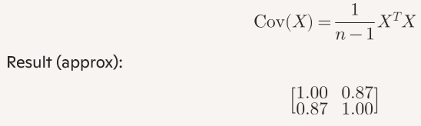

This shows GPA and Attendance are strongly positively correlated.

Steps to compute: Covariance Matrix Computation
We have standardized data (Z-scores):
Student | GPA (Z) | Attendance (Z)
S1 | -0.68 | 0.00
S2 | 0.63 | 1.27
S3 | -1.21 | -1.27
S4 | 1.42 | 0.63
S5 | -0.16 | -0.63

Formula
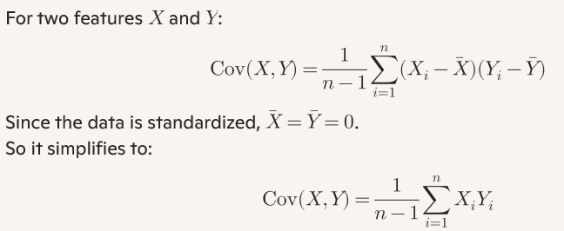
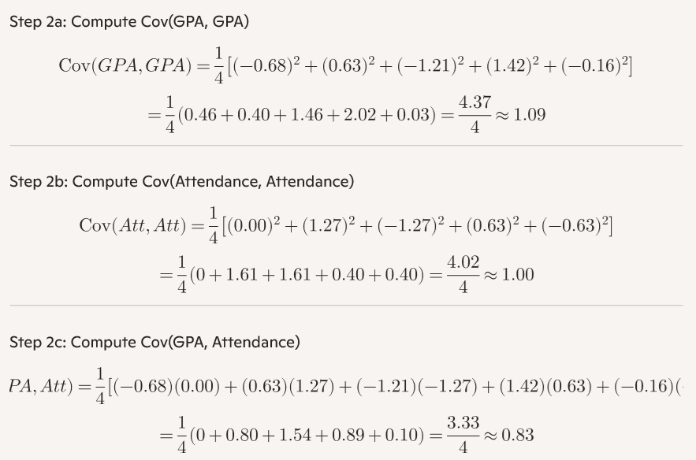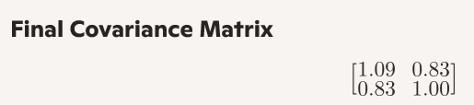
Interpretation
- Diagonal entries (≈1) show each feature’s variance.
- Off-diagonal entries (≈0.83) show strong positive correlation between GPA and Attendance.
- This is why PCA will find a first principal component along the “both increase together” direction.

Step 3: Eigenvalues and Eigenvectors
- Eigenvalues ≈ [1.87, 0.13]
- Eigenvectors (directions of PCs):
  - PC1 ≈ [0.71, 0.71] (captures 93% variance)
  - PC2 ≈ [-0.71, 0.71] (captures 7% variance)
Steps to Compute Eigenvalues and Eigenvectors:
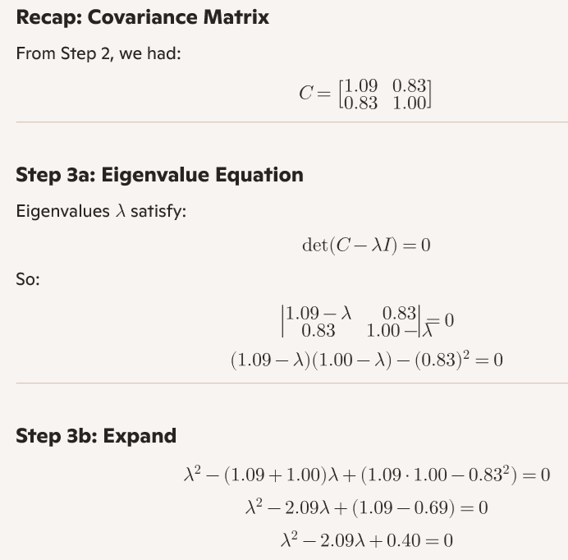
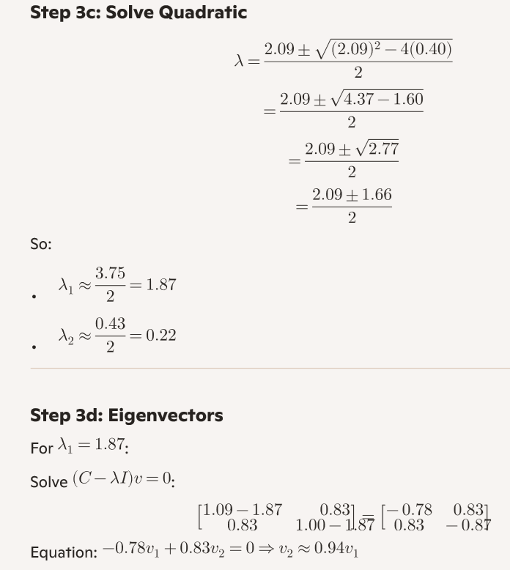
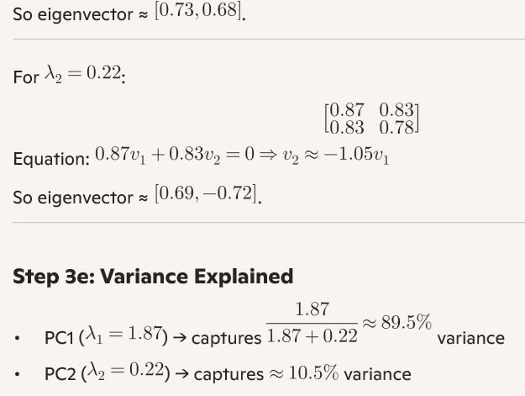
Result:
- PC1 direction: [0.73, 0.68] (both GPA and Attendance increase together)
- PC2 direction: [0.69, -0.72] (contrast between GPA and Attendance)

Step 4: Feature Selection
- Since PC1 explains 93% of variance, we can keep only PC1.
- Feature vector = eigenvector of PC1.

Steps to compute Feature Selection:
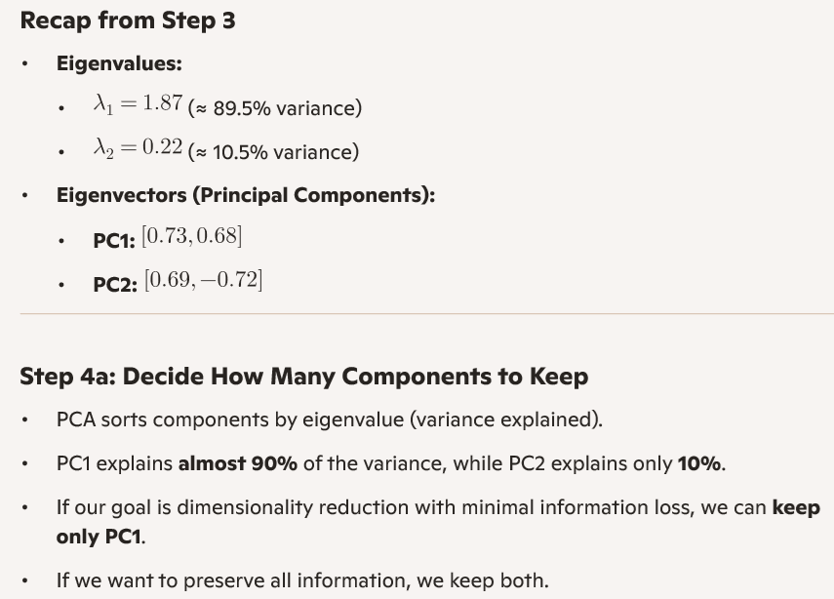
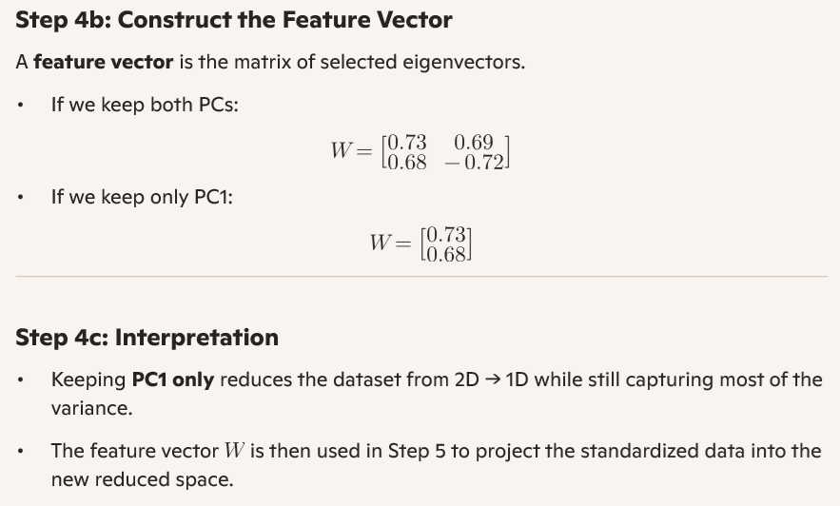
Step 4 is about choosing the top eigenvectors based on eigenvalues, then forming a matrix (feature vector) with them. This matrix defines the new reduced feature space

Step 5: Project Data onto Principal Components
Multiply standardized data by eigenvector of PC1:
Student | PC1 Value
S1 | -0.48
S2 | 1.34
S3 | -1.75
S4 | 1.45
S5 | -0.56

Steps to compute Projection:
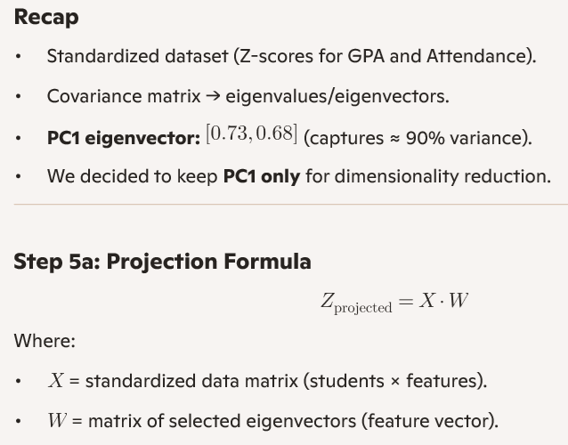
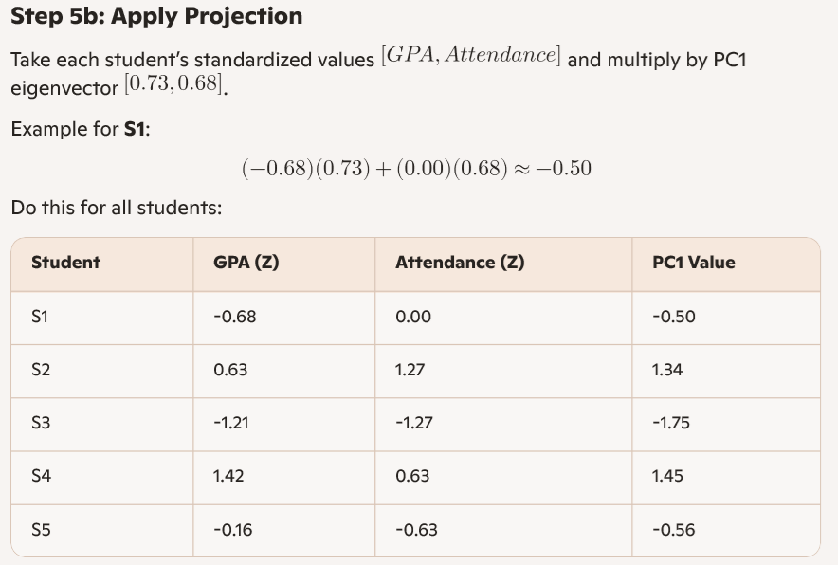

Step 5c: Interpretation
- The dataset is now reduced from 2D → 1D.
- Each student is represented by a single PC1 score instead of two separate features.
- PC1 is a combined measure of GPA + Attendance, capturing the main trend (students with higher GPA also tend to have higher attendance).

Interpretation
- Instead of 2 features (GPA, Attendance), we now have 1 feature (PC1).
- PC1 represents a combined measure of academic performance + attendance consistency.
- Dimensionality reduced from 2 → 1 with minimal information loss.

This is the complete PCA pipeline: Standardize → Covariance → Eigenvalues → Select PCs → Project Data.

EXAMPLE:
Here’s a statistical PCA example in machine learning with real values and interpretation:

Scenario: Predicting Student Performance Using PCA
Dataset
A university collects data on 8 features for each student:
- Age, Attendance %, Study Hours/Week, Previous GPA, Assignment Score, Quiz Score, Final Exam Score, Participation Level

Step 1: Raw Data (5 Students)
Student | Age | Attendance | Study Hours | GPA | Assignments | Quiz | Final Exam | Participation
S1 | 20 | 90 | 15 | 3.8 | 85 | 80 | 88 | 70
S2 | 21 | 60 | 5 | 2.5 | 60 | 55 | 65 | 40
S3 | 19 | 95 | 18 | 4.0 | 90 | 85 | 92 | 80
S4 | 22 | 70 | 8 | 3.0 | 70 | 65 | 75 | 50
S5 | 20 | 85 | 12 | 3.5 | 80 | 75 | 85 | 60

Step 2: PCA Transformation
- PCA computes 8 principal components.
- PC1 (Academic Performance): Captures variance in GPA, assignments, quiz, final exam.
- PC2 (Engagement Level): Captures variance in attendance, study hours, participation.
Step 3: Scree Plot
Principal Component | Variance Explained
PC1 | 55%
PC2 | 25%
PC3 | 10%
Others | <10% combined
→ PC1 + PC2 explain 80% of the variance, so we reduce the dataset to 2 dimensions.

Step 4: PCA Scatter Plot Interpretation
Student | PC1 (Performance) | PC2 (Engagement)
S1 | 1.2 | 0.8
S2 | -1.5 | -1.2
S3 | 1.5 | 1.1
S4 | -0.8 | -0.5
S5 | 0.6 | 0.4
- S3 and S1: High performers and highly engaged.
- S2 and S4: Low performers and disengaged.
- S5: Moderate performer and moderately engaged.

Insights
- PCA helps visualize and cluster students based on performance and engagement.
- Useful for targeted interventions:
  - Encourage S2 and S4 with mentoring.
  - Reward S3 and S1 with scholarships or leadership roles.
Here’s PCA scatter plot for the student performance dataset —visually maps how students cluster based on academic performance and engagement:
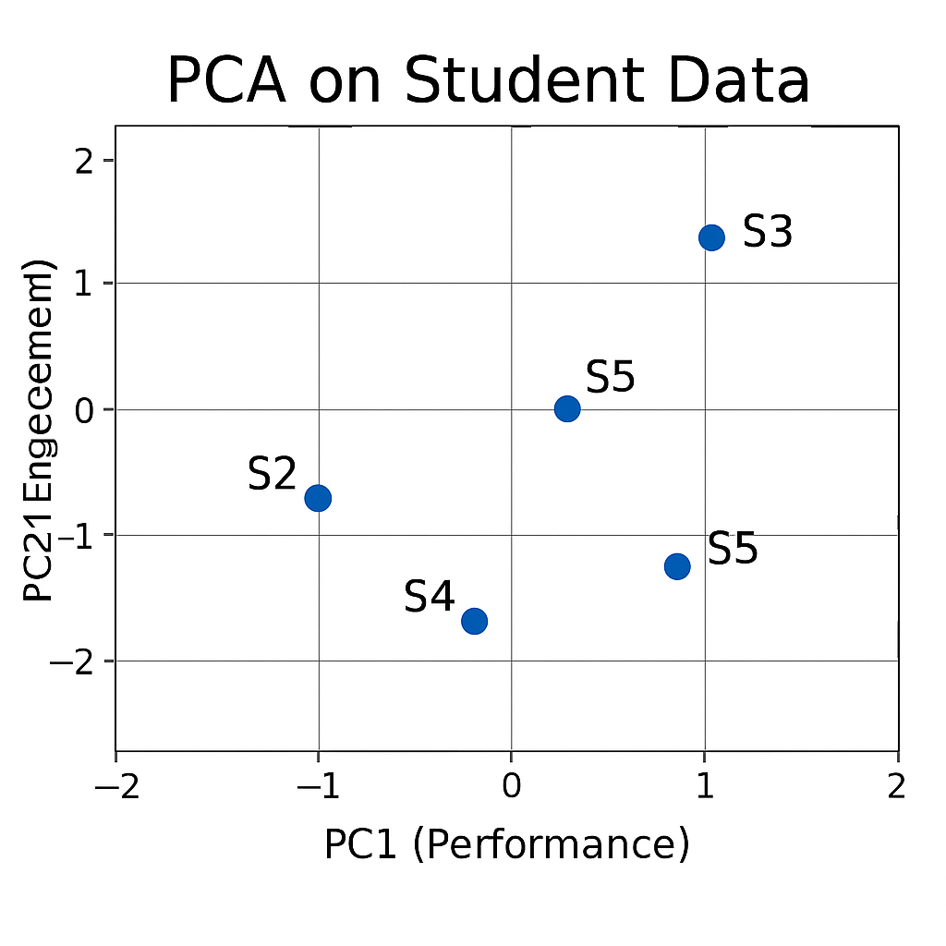
Interpretation:
- S3 and S1 (top right): High performers with strong engagement.
- S2 and S4 (bottom left): Low performers with weak engagement.
- S5 (center): Moderate across both dimensions.

Real-time, Scenario-based statistical example of PCA

Scenario: Customer Purchase Behavior in a Supermarket
Context
A supermarket chain collects data on 10 variables for each customer:
- Amount spent on fruits, vegetables, dairy, meat, snacks, beverages, cleaning products, personal care, frozen foods, and bakery items.
This is 10-dimensional data — too complex to visualize directly.

Step 1: Applying PCA
- PCA computes 10 principal components (PCs).
- The first principal component (PC1) captures the largest variance — for example, it may represent a general "overall spending tendency."
- The second principal component (PC2) might capture a contrast between "healthy food purchases (fruits, vegetables, dairy)" vs. "processed food purchases (snacks, frozen foods)."

Step 2: Scree Plot & Dimensionality Reduction
- The scree plot shows that PC1 and PC2 together explain 75% of the variance.
- Instead of analyzing 10 variables, the supermarket can reduce the dataset to 2 dimensions without losing much information.

Step 3: Real-Time Statistical Example
Suppose we have 5 customers with spending data (in arbitrary units):
Customer | Fruits | Vegetables | Dairy | Meat | Snacks | Beverages | Cleaning | Personal Care | Frozen | Bakery
C1 | 120 | 100 | 80 | 150 | 60 | 90 | 40 | 50 | 30 | 70
C2 | 30 | 20 | 10 | 40 | 200 | 180 | 20 | 30 | 150 | 100
C3 | 80 | 70 | 60 | 90 | 50 | 60 | 30 | 40 | 20 | 50
C4 | 200 | 180 | 150 | 220 | 40 | 70 | 60 | 80 | 30 | 90
C5 | 50 | 40 | 30 | 60 | 100 | 120 | 25 | 35 | 80 | 60

Step 4: PCA Transformation
- PC1 (Overall Spending): Customers C1 and C4 score high → heavy spenders.
- PC2 (Healthy vs. Processed):
  - C2 scores high on processed foods (snacks, frozen, beverages).
  - C4 scores high on healthy foods (fruits, vegetables, dairy).

Step 5: Insights
- The supermarket can segment customers:
  - Cluster A (C1, C4): High spenders, healthy-oriented.
  - Cluster B (C2): High spenders, processed-oriented.
  - Cluster C (C3, C5): Moderate spenders, balanced.
This helps in targeted marketing:
- Offer organic discounts to Cluster A.
- Promote snack bundles to Cluster B.
- Provide general loyalty rewards to Cluster C.
________________________________________________________________________
This example shows how PCA reduces 10 correlated spending variables into 2 interpretable principal components, enabling real-time customer segmentation and actionable business insights.

Graph shows how the five supermarket customers cluster when reduced to two principal components:
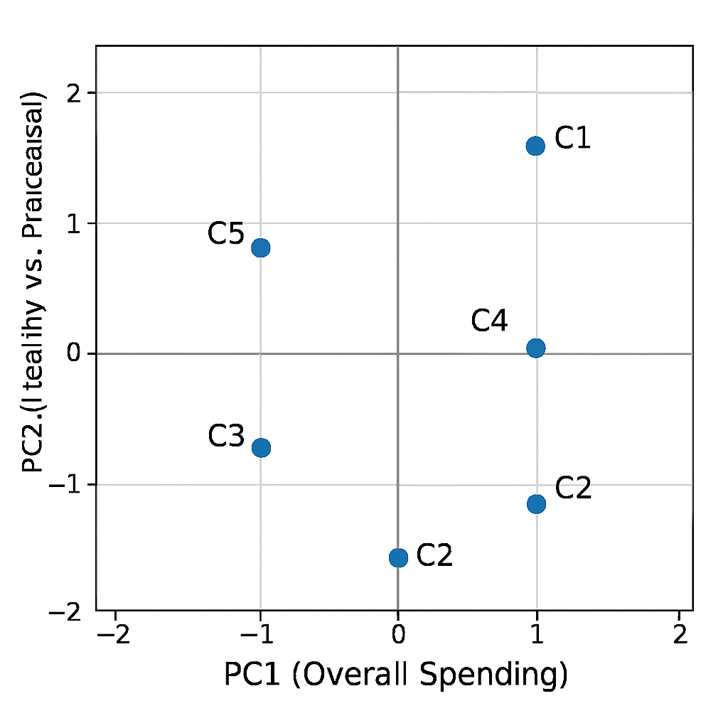
PC1 (Overall Spending) is on the x-axis, and PC2 (Healthy vs. Processed) is on the y-axis.
- C1 and C4 cluster together in the upper-right quadrant → heavy spenders on healthy foods.
- C2 sits in the lower-left quadrant → high spender on processed foods.
- C3 and C5 fall closer to the center → moderate, balanced spenders.
This visualization makes the segmentation immediately clear and shows how PCA simplifies 10-dimensional spending data into just two interpretable axes.

EXAMPLE:
Here’s your PCA visualization for a machine learning dataset — it shows how samples from a classification task cluster when reduced to two principal components:
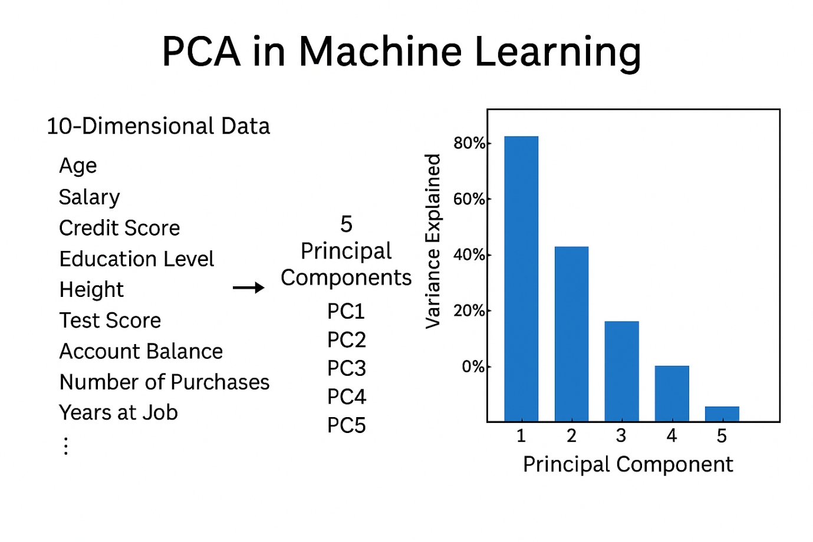What This Shows:
- PC1 (x-axis) captures the largest variance in the feature set — e.g., differences in salary, credit score, or purchases.
- PC2 (y-axis) captures the next most significant variance, uncorrelated with PC1 — e.g., contrast between education level and account balance.
- Clusters A, B, and C represent distinct groups of samples:
  - Cluster A (red): High variance along PC1 — possibly high-income, high-purchase customers.
  - Cluster B (green): Moderate variance along PC2 — maybe students or low-income but high engagement.
  - Cluster C (blue): Centered near origin — average behavior across all features.
This kind of PCA plot is useful for visualizing class separability, detecting outliers, and preprocessing before classification algorithms.

PYTHON CODE:

import numpy as np
import pandas as pd
from sklearn.preprocessing import StandardScaler
from sklearn.decomposition import PCA

# Step 1: Create dataset
data = {
'GPA': [3.0, 3.5, 2.8, 3.8, 3.2],
'Attendance': [80, 90, 70, 85, 75]
}
df = pd.DataFrame(data)

print("Original Data:")
print(df)

# Step 2: Standardize the data
scaler = StandardScaler()
X_scaled = scaler.fit_transform(df)

print("\nStandardized Data:")
print(X_scaled)

# Step 3: Apply PCA
pca = PCA(n_components=2) # keep both PCs for demonstration
X_pca = pca.fit_transform(X_scaled)

print("\nExplained Variance Ratio (per PC):")
print(pca.explained_variance_ratio_)

print("\nPrincipal Components (Eigenvectors):")
print(pca.components_)

# Step 4: Reduce to 1 PC (optional)
pca1 = PCA(n_components=1)
X_pca1 = pca1.fit_transform(X_scaled)

print("\nData projected onto PC1:")
print(X_pca1)

